**Introduction to Computer Science – Harvard’s CS50**

1. **Computational Thinking & Scratch – Intro to Computer Science(week 0)**

Computer science is about problem solving

H I (letter ascii)

72 73 (decimal numbers)

1001000 1001001 (binary 8 bit)

Abstraction – converting lower level details into more simplified version and focus on problem solving

Since there are so many languages that cannot be represented by 8 bit(256 different type of possibilities), now we use Unicode or utf-8 which uses 16 bit(2 to 16th power or 65536 different possibilities).

Rgb – a dot, pixel, uses three byte per pixel, how many red, how many green, how many blue per pixel.

An image is a group of pixels using three bytes(24 bit) in total of kilobytes, megabytes, and so fourth.

A video is a collection of images, 24 fps(frames per second) example, showing 24 images per second, showing a sequence of static images and makes it look like a moving video.

Videos -> images -> colors -> bits -> frequency of electricity

Input -> algorithms -> output

Pseudo code – a simplified programming language

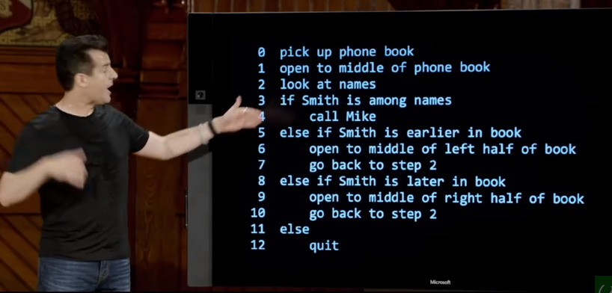 verbs here are functions, questions like if else if are conditions, smith is among names is Boolean expression, go back to step2 loops

Gigahertz – GHz is a unit of measurement for AC(alternating current) or em(electromagnetic) wave frequencies equal to one billion hertz.

1. **C Programming Language(week 1)**

Now a day, computers are performing billions of things in a second gigahertz speed, a more readable code is more preferred in some cases.

Input | Source code – code we humans have written using java, c, python

Compiler

Output | Machine code – 0 and 1s

Ram – temporary storage, has finite number of transistors which means there are finite of values that can be represented and stored accurately. For example, when you divide a number and add 50 more decimal place holders, the number that is displaced is imprecision, very micro value but still imprecision. For this reason finance displays dollars up to the thousands place, because back in the days when this was not obvious, people made money by adding up penny values.

When value reaches its’ max value, it overflows and returns to the beginning.